CMPE 306

Spring 2020

Lab 4: Thevenin’s Theorem and Power Transfer

Nem Negash

February 25th, 4-6PM

**Purpose**

The purpose of this lab is to understand Thevenin’s theorem and be able to analyze and design linear circuits to a simpler and equivalent circuits. Thevenin's Theorem takes a complex circuit and breaks it down into a circuit containing only an independent voltage source and a single resistor. The lab also involved finding the power transfer in the Thevenin circuit and finding what resistor would get the maximum power transfer.

**Equipment**

1. ELVIS-II 5V fixed DC voltage source and ELVIS-II 12V variable voltage source,
2. Digital multi-meter with probe cables
3. ELVIS-II Breadboard
4. 25kΩ potentiometer
5. Resistors: 510Ω, 1kΩ,1.5kΩ, 3kΩ, 2x5.1kΩ, 6kΩ, 7.5kΩ, 2x10kΩ, 33kΩ, 62kΩ, and 100kΩ
6. Red and black alligator cables

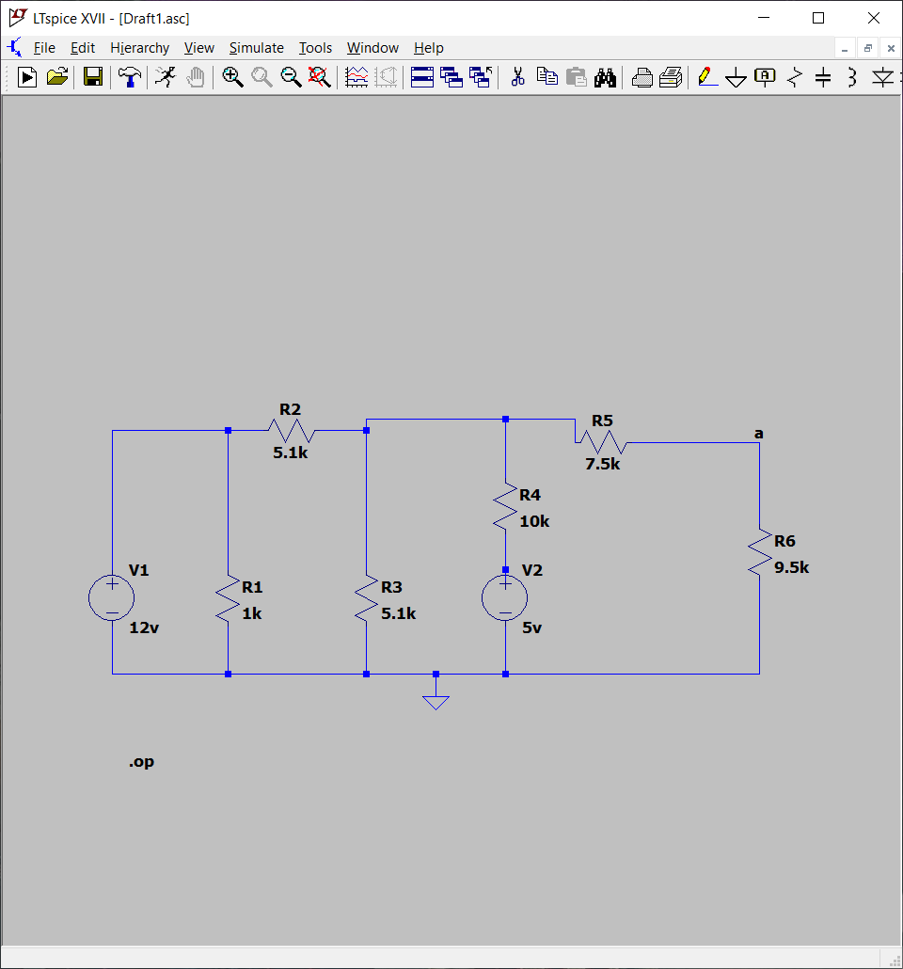

**Procedure**

1. Using the multimeter, measure and record the actual value of all resistors.
2. Using the equipment, construct circuit seen in Fig. 1
3. Using the multimeter, measure voltage between points A and B
4. Calculate Thevenin's Resistance using the short circuited current and voltage between A and B
5. Using the multimeter, measure the resistance between the center lead and both side leads of the potentiometer
6. Use the multimeter to measure the voltage across the potentiometer, and adjust the potentiometer until voltage across it is equal to 50% of step 3's result
7. Remove the potentiometer. Repeat step 5. Compare to result of step 4
8. Place a known resistor between A and B. Measure the voltage across the resistor. Compute the Thevenin's Resistance using the equation: **Vab / R = Vopen / R+ Rth**
9. After modifying the multimeter, Measure the current through the resistance from step 8. Compute the Thevenin's Resistance using the equation: **Vopen = Ir x (R + Rth)**
10. Turn the variable source off. Disconnect the two voltage sources from the circuit and connect them to ground. Use the multimeter to measure the resistance between points A and B.
11. Use the multimeter to measure the actual values of these resistors: 510Ω, 1.5kΩ, 3kΩ, 6.2kΩ, 10kΩ, 33kΩ, 62kΩ, and100kΩ
12. Connect each of the resistors between terminals A and B, and measure the voltage across the resistor.
13. Construct a new circuit containing the voltage found in step 1, and Thevenin's Resistance found in various steps.
14. Repeat step 12 with the new circuit.
15. Using the resistor values as the independent variable, and the load power as the dependent variable, plot the results of step 12 and 14, and the theoretical results.

**Measured Data**

Vopen (as found in step 3) = 5.7794 Volts

Iss (as found in step 4) = 0.00056 A/0.56 mA

Resistance of potentiometer at 50% voltage = 9.015 kΩ

Vab (as found in step 8 and using 10 kΩ) = 2.9456 Volts

Ir (as found in step 9) = 0.00036 amps

**Results from Step 11 Results from Step 12 and 14**

|  |  |
| --- | --- |
| **Labeled Resistance** | **Actual Measured Resistance** |
| 510 Ω | 501.88Ω |
| 1.5k Ω | 1.47k Ω |
| 3k Ω | 2.98k Ω |
| 6.2k Ω | 6.09k Ω |
| 10k Ω | 9.83k Ω |
| 33k Ω | 32.6k Ω |
| 62k Ω | 61.51k Ω |
| 100k Ω | 97.56k Ω |

|  |  |  |
| --- | --- | --- |
| **Labeled Resistance** | **Voltage between points A - B** | **Voltage between Thevenin's Circuit** |
| 510 Ω | 0.29 V | 0.29 V |
| 1.5k Ω | 0.78 V | 0.79 V |
| 3k Ω | 1.38 V | 1.39 V |
| 6.2k Ω | 2.26 V | 2.28 V |
| 10k Ω | 2.94 V | 2.94 V |
| 33k Ω | 4.47 V | 4.46 V |
| 62k Ω | 5.00 V | 4.98 V |
| 100k Ω | 5.27 V | 5.23 V |

**Thevenin’s Resistance =** 9.982 kΩ

**Calculations**

The first equation used was in step 8, to find the voltage between points A and B, the equation being: **Vab / R = Vopen / R+ Rth.** Resistance 10k Ohms was used.

**Vab /** 10000 Ohms = 5.7794 V / (10000 Ohms + 9982 Ohms)

**Vab = 2.89 V**

The next equation used was in step 9, when calculating Rth after finding the current through the circuit when short circuited, the equation being **Vopen = Ir x (R + Rth)**

5.7794 V = 0.00036 A x (10000 Ohms + Rth)

**Rth  = 6053.9 Ohms**

The last equations used were to find the power load of the load resistance, both when using the known circuits and a theoretical Thevenin’s voltage and resistance. The equation for the known circuits was: **P = V2 / R** , and the equation for the theoretical voltage and resistance was:  **P=(Vth/(RTh + RL))2 x RL ,** where RL was the load resistance.

**Conclusion**

Through the lab, my lab partner and I learned how to use Thevenin’s theorems to take a complex circuit and simplify them into simpler but equivalent circuits. I also learned that the Thevenin equivalent circuit supplies the maximum power when the load resistor and the load resistor are equal. As the graph above shows the highest amount of power supplied is when the load resistor was around the Thevenin resistor at about 9.982k Ohms. The equation used in step 9 was able to find Thevenin’s resistance as well, due to nodal analysis, such as when points a and b are short circuited by the chosen resistance (2000 ohms). Finally, when comparing the power load across the chosen resistors, the discrepancies were due to inaccuracies in the potentiometer, and inexact values of the resistors.